Education Monitoring and Review – Guidance

This guidance document will assist in the completion of the template forms for Education Monitoring and Review (EMR). If you encounter any difficulties not covered here, please contact [emr@admin.cam.ac.uk](mailto:emr@admin.cam.ac.uk) for assistance.

Contents

What is EMR and why has it been implemented? 2

What is expected? 2

Step 1: Data review 3

Step 2: Write submission 3

Collaborating on your submission 4

Step 3: Submit 4

Step 4: Review 4

Step 5: Report 4

Data sets and use of Tableau 6

How to get access to Tableau 6

Completing the form 6

Using Tableau and getting help 6

About the data 7

Template Forms 9

Taught course forms (UG/PGT) 9

Section 1: Admissions 9

Section 2: Course structure 9

Section 3: Teaching and learning 10

Section 4: Assessment 11

Section 5: Student feedback 11

Research course forms (PGR) 12

Section 1: Admissions 12

Section 2: Education and training 12

Section 3: Assessment 12

Section 4: Student feedback 13

Timescales 14

# What is EMR and why has it been implemented?

Education Monitoring and Review (EMR) is a University quality assurance process which will provide evidence-based, regular review of courses for quality monitoring and enhancement.

EMR will enable the University to evidence the high quality of its education, and to demonstrate continual enhancement of academic standards. It will also enable the University to systematically share good practice between and across cognate disciplines, and to take action to support areas of weakness. EMR reports to the Academic Standards and Enhancement Committee and is operationally managed by the Education Quality and Policy Office (EQPO), in collaboration with Schools and the Institute for Continuing Education.

Departments will review an institutional data set primarily held in Tableau dashboards to inform a reflective summary, which is submitted on a standard template form.

EMR will provide collaborative, constructive support to departments. It is not intended to be heavy-handed or burdensome; both Departments and Schools will already be reviewing the same data annually, but in many cases those reviews are organic, or taking place in silos. EMR pulls this reflection into a more systematic, holistic process, which also takes place jointly with Schools and ICE to better embed the actions from these reflections within strategic planning. While the process is comparative in the sense of identifying common challenges or benefits across cognate disciplines, it is not a performance-monitoring exercise; issues and concerns are discussed with a supportive and future-facing mindset, rather than for punitive or policing purposes.

There are three formal stages of EMR: *Standard Monitoring*, *Enhanced Monitoring*, and *Referral to the General Board*. It is anticipated that most, if not all, submissions will be managed via *Standard Monitoring*; this guidance therefore only details those steps. Should further stages be necessary, more detailed guidance will be provided.

Full details about EMR, including rationale and stages, are available in the [Overview document](https://www.educationalpolicy.admin.cam.ac.uk/ensuring-quality/quality-processes/emr).

# What is expected?

*Standard Monitoring* of Education Monitoring and Review has 5 steps:

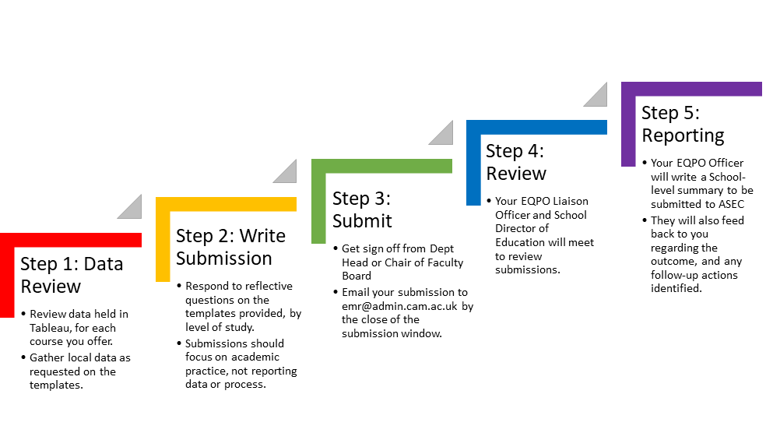

## Step 1: Data review

Departments will need to access the EMR Dashboard in Tableau. More information about the dashboards is provided in the section on *Data Sets and use of Tableau*, below, and this guidance includes links to the EMR dashboard (and others you may wish to use) within the section on *Template forms**.* Data is presented by course, and provides data on admissions, overall degree class and examination results, continuation and completion of students, and progression after graduation.

Wherever possible, please use central data in Tableau rather than local data relating to intermission, withdrawals, examination (for undergraduates), admissions or outcomes; in some cases it may be appropriate to supplement central data with local data. The purpose of using central data is that this is approved, cleaned data which is used for statutory reporting. Data held locally is not verifiable, and often only accessible by those with local access. We want to move towards using central datasets whenever possible.

The University is taking steps to enhance the data supporting education and we anticipate that this will be continually in development; we want to use EMR to support this enhancement, and welcome comments on the availability or use of data via Tableau.

## Step 2: Write submission

Departments will make their submission by responding to reflective questions on template forms. There are three forms: one for undergraduate courses, one for postgraduate taught courses, and one for postgraduate research courses.

Forms are divided into sections; each of these is outlined in more detail in the *Template Forms* section of this guidance. Questions seek targeted reflection on trends which you may see from the data provided.

**It is important to note that, when completing the form, we are seeking critical reflection on your educational practice, and not description of data or process. Equally, the data to be used is largely from shared institutional datasets, and so little value can be found in reporting or replicating it. There is no “right answer” or threshold metric we are seeking; instead, what is important is what the data means to you and your educational practice. The purpose of EMR is to stimulate reflection on your courses and the particular context in which they operate.**

As an example, a statement such as: “Women account for 36% of applications for the MPhil in Oceanic Studies” would be unhelpful, as it does not provide any reflection or context for the data. Is 36% good or poor? Is this a surprising result given previous years’ profiles? How does that align with offers made and converted places? Do you intend to take any action to change this percentage, and if so what and why? Similarly, with examination statistics, we are not seeking reporting of the number of 1, 2.i, etc., or a description of how you moderate marks; we are looking for critical reflection on results in light of student profiles, trends across years (with particular relevance to changing assessment practices), and future plans to diversify assessment and how you anticipate this might impact on results.

While there is no formal limit to the size of your submission, it is important to note that EMR is not intended to be a lengthy exercise. We are seeking reflection across a wide range of topics, but not all of these will necessarily generate significant discussion. Across the whole of your submission we would suggest a word limit of around 1500-2000 words is sufficient for the level of detail expected; however, you are not limited and you are welcome to provide more detail if this is relevant to your particular context. Please do seek advice from the EMR team if you are unsure on the level of detail required.

### Collaborating on your submission

We do not anticipate that forms will be completed by a single individual; instead, sections can be collaboratively completed by a number of staff within the Department. The final submission is owned by the Faculty Board and **must be signed off** by either the Head of Department or the Chair of the Faculty Board (or related body, such as Tripos Management Committee).

Students should be involved in the creation of your reflective summary, in particular the section on student feedback. However, it is inappropriate to share direct data sources, or any potentially identifiable data with them. It would be entirely appropriate, however, to share your responses or to provide them with summarised data review.

## Step 3: Submit

Submissions should be made via email, sending the relevant form(s) to: [emr@admin.cam.ac.uk](mailto:emr@admin.cam.ac.uk). The sign off by Head of Department or Chair of Faculty Board may be included as part of the form itself, or by email (attached to the submission, or sent under separate cover).

Submissions should be sent before the close of the submission window (see *Timescales*, below). You will receive an email confirming receipt.

This is the end of Departmental action; the remaining steps will be carried out by the Education Quality and Policy Office and School or ICE senior academic leaders.

## Step 4: Review

Every teaching institution has a dedicated Education Quality and Policy Liaison Officer. After submission, this Officer will meet with the relevant senior academic leader(s) in the School or ICE to collaboratively review the submissions. A member of the Postgraduate Research Office (PGRO) will also attend to advise and discuss PGR submissions. At the discretion of the School or ICE, representatives from the Departments or from cognate areas may be asked to attend to discuss the submission in more depth.

They will be looking for commonalities in the reflections, particularly across cognate disciplines. For example, are all courses looking to implement changes as a result of access or participation goals, or what challenges are these types of courses facing with regard to engaging with strategic priorities? They will identify what advice and guidance can be provided to assist, centrally or at the School level, and whether there is good practice in one area that may help to address issues identified elsewhere. This will form the basis of further discussions or follow-up actions as necessary.

## Step 5: Report

After the review meeting, the EQPO Officer and PGRO representative will write a summary, which will be reviewed by the relevant senior leaders. This summary will then be reported to the Academic Standards and Enhancement Committee (ASEC), with any issues relevant to PGR provision also considered by the Postgraduate Committee. ASEC will take a University-level approach to the monitoring, pulling together common themes across all those participating in EMR and reporting annually to the General Board’s Education Committee (GBEC).

The Officer will also feedback to Departments about the outcome of the review, and any follow-up actions that have been identified.

# Data sets and use of Tableau

The data to be used in reflection should, in the main, be drawn from centrally-held sources wherever possible; however, there are areas (indicated on the form and in this guidance) in which you may need or wish to supplement this with locally-held data. If you do supplement with local data, you do not need to provide this with your submission.

The University has provided an Education Monitoring and Review dashboard in Tableau, which pulls together the primary sources, although you may wish to also utilise other dashboards available in the Shared area of Tableau and for admissions data can access this [here](https://tableau.blue.cam.ac.uk/t/InformationHubPublic/views/CambridgeUndergraduateAdmissionsStatistics/Home?%3Aembed=y&%3AisGuestRedirectFromVizportal=y) . Tableau enables powerful visualisation of data across years and makes it easier to pull together trends and insights.

## How to get access to Tableau

Tableau is available to University and College members who meet particular [eligibility criteria](https://www.information-hub.admin.cam.ac.uk/tableau/tableau-server-access/tableau-server-eligibility-criteria); we anticipate that staff participating in EMR from all Departments will meet this criteria, although in the case of support by temporary members of staff an additional case may need to be made. If you require support in making an additional case, please contact [emr@admin.cam.ac.uk](mailto:emr@admin.cam.ac.uk) in the first instance.

To access Tableau, users must navigate to the following page: <https://www.information-hub.admin.cam.ac.uk/tableau/tableau-server-access> , and login using their CRSid and UIS password.

All data for Education Monitoring and Review is in a shared project, and so **you do not require access to any additional folders**; please ignore this section. You may note that there are folders listed for Postgraduate Admissions or Careers, but these are not relevant for EMR.

## Using Tableau and getting help

The dashboard has both a “Contents” tab, providing details of the data sources used, and a “Read Me” tab, which gives the following information:

* What data is in this dashboard and why is it important
* What are the indicators represented (e.g., what is meant by ‘continuation’ data)
* What academic years are included and how these are different across indicators
* Any other additional contextual information about the data provided (for example, defining measures of relative deprivation or subject coding)

You can then access the individual folders for each data source from the main page:

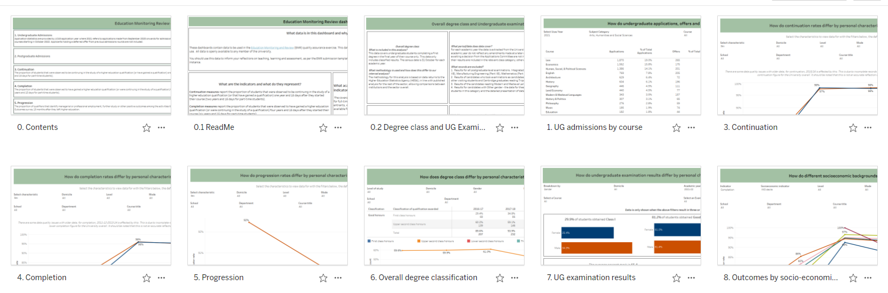

Or, if you are in one of the tabs already, you can navigate to others using the menu at the top:

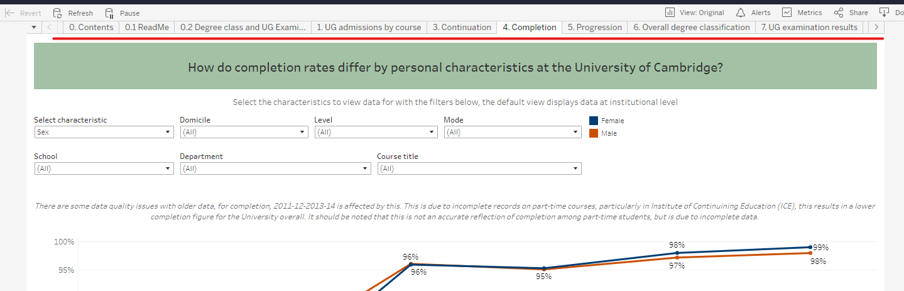

The Business Information and Strategic Insights team has provided detailed training about the dashboards available and how to utilise them to gain insight on your data, which is available here: <https://www.information-hub.admin.cam.ac.uk/tableau/tableau-server-training>. This is self-directed training via step-by-step pdfs as well as videos and includes exercises to test knowledge. Classroom training is available on a limited basis; see details at the link.

If you wish to have additional training, or have trouble using Tableau, please contact the EMR team at [emr@admin.cam.ac.uk](mailto:emr@admin.cam.ac.uk) in the first instance.

## About the data

Data in the EMR dashboard is pulled from a number of different sources. As a result, the years covered by each indicator and the metrics available will vary from tab to tab. We also aim to add tabs as EMR progresses.

Where the guidance requests you to reflect on a particular timescale, for example “the past 3 years”, this should be interpreted as the past 3 years’ worth of available data. Some indicators present data by cohort, which means that the most recent years’ worth of data will be the 2016-17 academic year. The “Read me” tab on each dashboard will provide guidance about the data sources, year coverage, and indicators used.

There may also be quality issues with older data (noted in the dashboards themselves), which result from changes to coding measures over time, and incomplete records on part-time courses. This is one reason why we are seeking your reflections on the data and its context to your courses; we want to know if you feel the data accurately reflects your course(s), or possible reasons why not.

While we believe that sufficient and relevant data is available centrally for all courses, if you encounter issues this should not hinder your ability to respond to the reflective questions in the template. If you find that a particular data source has limitations for your course(s), you may supplement this with local data. We do not, however, expect you to expend significant resource in collating or querying local data sources, and these do not need to be returned with the form (for example, providing us with three years’ worth of spreadsheets of exam results). We also welcome reflections on the impact of this lack of data for your planning, as we are committed to continually improving the relevance and usefulness of centrally-held data sources. We do not envisage any departments submitting a type of “nil return” for any section in the form; some level of reflection should always be possible.

If you have any queries regarding limitations in the data sets provided, please contact us at [emr@admin.cam.ac.uk](mailto:emr@admin.cam.ac.uk) to discuss.

# Template Forms

Three forms are provided, one for each of Undergraduate, Postgraduate Taught, and Postgraduate Research courses. These are all available on the EMR [website](https://www.educationalpolicy.admin.cam.ac.uk/ensuring-quality/quality-processes/emr).

While data is reviewed for each course individually, submissions are completed for all courses at the same level of study (for example, all postgraduate taught courses that you offer). At the start of the form, you are asked to list the courses covered by the submission; this is intended to ensure that reviewers understand the datasets used and context for the reflections in the submission.

*Note for 1+3 courses*

We recognise that there are a number of models for these courses which cover both PGT and PGR. A 1+3 course may be included on either the postgraduate taught or the postgraduate research form, whichever you feel more appropriate.

## Taught course forms (UG/PGT)

The undergraduate and postgraduate taught forms are divided into six sections:

1. Admissions
2. Course structure
3. Teaching and learning
4. Assessment
5. Student feedback
6. Additional information requested by the Academic Standards and Enhancement Committee (ASEC); *note that this section will not appear on the form unless specific information has been requested*

### Section 1: Admissions

Data for the admissions section can be found in the Tableau [EMR dashboard](https://tableau.blue.cam.ac.uk/#/site/InformationHub/workbooks/1368/views); undergraduate data will be on Tab 1, and postgraduate data on Tab 2.

For this section, we are particularly seeking reflection on your admissions goals and targets, both the ways in which they shape and are shaped by your course(s). This might include reflection on total applications vs places offered, comments on the typical applicant profile, numbers of home/overseas students and how this may relate to your course, or the ways in which admissions assessments aid your consideration. One question specifically seeks comment on activities to understand, and address, any access or widening participation goals.

*Note for interdisciplinary courses:*

We recognise that in some cases, students will be recruited independently of the Department submitting the reflective summary (for example, on courses with a devolved Part II or III structure). However, we would still welcome reflections on your current student cohort, or the ways in which admissions may impact your course(s).

### Section 2: Course structure

You may wish to reflect here on ways in which your course structure helps to address particular challenges you have identified for the student experience – an example may be the creation of a block of research methods skills, in response to student feedback.

### Section 3: Teaching and learning

The purpose of this section is to prompt reflection on the ways in which your course supports students to achieve success, as well as methods for enhancing your educational practice. You are asked for details of your teaching practice, as well as to reflect on data regarding completion, continuation, and destinations after study.

Data for completion, continuation, overall degree class and examination results (undergraduates only), and progression can be found on Tableau in the [EMR dashboard](https://tableau.blue.cam.ac.uk/#/site/InformationHub/workbooks/1368/views). For home students, there are also dashboards here covering various socioeconomic indicators such as students’ qualifications on entry, and the indices of multiple deprivation, which provides insight into relative deprivation based on the student’s location of permanent residency. These indicators may be useful in evaluating the impact different socioeconomic backgrounds have on students’ outcomes and experiences at the University. You are also prompted to use the [Graduate Outcomes dashboard](https://tableau.blue.cam.ac.uk/#/site/InformationHub/workbooks/1300/views) to inform your reflections in this section; this contains information on destinations post-study, gaps in outcomes on student characteristics, and salary information.

Reflections in this section might be prompted by student workload, whether this is overall, balance over terms, or comparison between different courses at the same level of study. You may also wish to consider the ways in which you support transition to study on your courses. We recognise that transition needs will be different for different types of courses; here again we are not seeking only report of what you do, but rather *why* your transition package is the most effective offering to enable success on your course(s). Where you offer more than one course at the level of study, you may also find useful reflection in comparing the differing transition packages offered; we welcome comment on how variation of transition or induction activities aligns with course content and applicant profile.

The template asks for reflection on intermissions or withdrawals using central data on continuation and progression; we ask that you do not use local data for this purpose because of the risk of potential identifying information. While you may be aware of personal student circumstances, please note that we are seeking trends rather than specific student examples. The aim here is not to police the level or number of your withdrawals, but rather to prompt reflection on whether commonalities in withdrawal might be seen, and what this might mean for your course(s), student support, transition, or other measures.

### Section 4: Assessment

The purpose of this section is to seek specific reflection on assessment practices and student achievement. Undergraduate data can be found in the Tableau [EMR dashboard](https://tableau.blue.cam.ac.uk/#/site/InformationHub/workbooks/1368/views), as noted above in Section 3. Postgraduate results data is not currently held in Tableau, although we are working to include this for future; you can access data on student progression and completion in Tableau, via the [EMR dashboard](https://tableau.blue.cam.ac.uk/#/site/InformationHub/workbooks/1368/views) and on post-study destinations in the [Graduate Outcomes dashboard](https://tableau.blue.cam.ac.uk/#/site/InformationHub/workbooks/1300/views). You may need to supplement this with local data on student results.

We recognise that assessment cannot be entirely separated from teaching and learning, so there may be overlap between your reflections here and in Section 3. However, what we aim for in this section is reflection on the ways in which assessment supports student achievement and outcomes; not only in terms of awarding gaps and/or grade inflation (though you are asked to reflect on these), but also with regard to course structures and design. For example, how do early assessments support students to develop skills for later assessments? Have changes made to assessments in recent years addressed any awarding gaps, or do you have plans to evaluate or implement further changes?

You might also find useful reflection with regard to earlier sections on student workload, or comparison between courses at that level of study. For example, how does the design of assessments support students to develop particular skills or meet learning outcomes? Does assessment weighting appropriately reflect the importance of relevant learning outcomes? Is one course in particular more/less heavily assessed, and is this appropriate with regard to particular student profiles?

### Section 5: Student feedback

In this section we are seeking reflection on the ways in which you seek feedback from students, as well as trends you may have seen over cohorts or years. This should cover both consultation and evaluation – that is, ways in which you consult with students over major issues or changes, as well as more regular evaluation or feedback (i.e., module or paper-level surveys).

The data for this section will be a mix of central and local sources. You will need to collate data from local course or module evaluations, as well as from your Staff-Student Joint Committee or similar bodies; local data does not need to be provided with your submission. Longitudinal data for the National Student Survey (for undergraduates) is available in Tableau in the [NSS dashboard](https://tableau.blue.cam.ac.uk/#/site/InformationHub/projects/119), as is data for the [Student Barometer survey](https://tableau.blue.cam.ac.uk/#/site/InformationHub/projects/94) (historical data only, as this survey is no longer run). Data for the Postgraduate Teaching Experience Survey (PTES, for postgraduate taught) is available only to a limited number of courses, as a result of low response rates. PTES data is not available in Tableau but has been sent to Departments; if you require this again please contact us at [emr@admin.cam.ac.uk](mailto:emr@admin.cam.ac.uk) to obtain a copy.

While we expect the full submission to be shared with students before submission, this section should be crafted in collaboration with student representatives.

## Research course forms (PGR)

Forms for postgraduate research courses have five sections:

1. Admissions
2. Education and training
3. Assessment
4. Student feedback
5. Additional information requested by the Academic Standards and Enhancement Committee (ASEC) or the Postgraduate Committee (PC); *note that this section will not appear on the form unless specific information has been requested*

### Section 1: Admissions

Data for the admissions section can be found in the Tableau [EMR dashboard](https://tableau.blue.cam.ac.uk/#/site/InformationHub/workbooks/1368/views); postgraduate data is on Tab 2. *Note that at time of publication this tab is being finalised and will not appear until early January 2023.*

For this section, we are particularly seeking reflection on your admissions goals and targets, both the ways in which they shape and are shaped by your course(s). This might include reflection on total applications vs places offered, comments on the typical applicant profile, numbers of home/overseas students and how this may relate to your course, or the ways in which admissions assessments or interviews aid your consideration. One question specifically seeks comment on activities to understand, and address, any access or widening participation goals.

We recognise that in some cases, students may be recruited independently of the Department submitting the reflective summary (for example, on an interdisciplinary 1+3 course where students select a specialisation for PhD study). However, we would still welcome reflection on the current makeup of your student cohort, and the ways in which these admissions may impact on your course(s).

### Section 2: Education and training

This section focuses reflections on how you equip students with the skills and expertise to carry out their independent research. This ranges from support for transition/return to study, data on completion, destinations, and continuation, and opportunities for researcher development.

When considering how to respond, please note that we recognise that student needs will be different for different types of courses; you will already be providing what you feel is the most effective method for your students, so we are interested in *why* your training package is particularly effective. Does it respond to needs for the average student profile, or take advantage of collaborative partnerships to which you have access? You may wish to include in this section some examples (provided that students are not identifiable) which you feel exemplify the type of research environment which you provide.

### Section 3: Assessment

In this section, we are seeking reflections on the ways in which you assess student progress through the course, or the attainment of particular milestones. This is likely to centre on the first-year registration exercise, but some courses may also offer formative elements throughout study.

As with elements of Section 2 above, we are particularly looking for reflections on *why* you have structured progression as you have (if this differs from the standard expectations as set out in the Code of Practice), or how you feel this provides students with the right support at the right time. If you offer more than one PGR course, we are also interested in any comparisons you might make on variance (if any) in assessment of progression, or whether there are particular challenges that may be addressed by adopting common solutions.

### Section 4: Student feedback

In this section we are seeking your reflections on ways in which you seek feedback from students on their educational experience, and how you close the feedback loop.

Data for this section will be from a mix of sources, both central and local. You will need to collate data from committees or other collaborative bodies, or other local sources of student feedback. Longitudinal data for the [Student Barometer survey](https://tableau.blue.cam.ac.uk/#/site/InformationHub/projects/94) is available in Tableau (historical data only, as this survey is no longer run). Data for the Postgraduate Research Experience Survey (PRES) is available only to a limited number of courses, as a result of low response rates.

While we expect the full submission to be shared with students before submission, this section in particular should be crafted in collaboration with student representatives.

# Timescales

Education Monitoring and Review has been designed with six-week submission ‘windows’, as a method to calibrate the anticipated effort from Departments in preparing the submissions. While you could begin earlier, please use the start date of the window as the data census date (using this as the point from which you review data back the requested number of years).

Submission windows are as follows:

|  |  |  |
| --- | --- | --- |
| Term | Window opens | Submission deadline  (window close) |
| Michaelmas 2023 | 13 Oct 2023 | 27 Nov 2023 |
| Lent 2024 | 8 Jan 2024 | 23 Feb 2024 |
| Easter 2024 | 10 Jun 2024 | 22 Jul 2024 |
| Michaelmas 2024 | 21 October 2024 | 5 December 2024 |

As noted above, EMR is designed to be a lighter-touch process than previous reviews. We anticipate that by far the majority of departments will be able to complete the data review and co-ordinate with staff responding to different sections within the 6-week period.

If you have difficulty with submission deadlines, please contact [emr@admin.cam.ac.uk](mailto:emr@admin.cam.ac.uk) in the first instance, as soon as possible. Review meetings will be arranged early and may limit the extent of flexibility we may offer with regard to submission deadlines.